

**Game Design**

Year 3 (2013/14), Semester 6

**SCHOOL OF INFOCOMM TECHNOLOGY**

Diploma in Information Technology

**ASSIGNMENT 1**

**Individual Proposal Submission**

|  |  |  |
| --- | --- | --- |
| **Student Name** | **Student ID** | **Grade** |
| Saklani Pankaj | S10117228A |  |
| Tan Yong Wei | S1011 |  |

Contents

Game 2 – dead survival 2

Summary 2

Game Story 2

Game Space 3

Goals of the Game 3

Avatars 3

Game Mechanics 4

Other Relevant Information 5

Game Visuals 5

Group Game Design Proposal

# Game 2 – dead survival

## Summary

This is a top down shooter with elements of tower defence. The main objective of the player is to survive the waves of zombies, while trying to make sure that their safe house does not get destroyed. Throughout the game, the player needs to constantly build defensive structures to tackle the waves of zombies that will get more and more difficult. Throughout the game the player can also make upgrades to his character, such as health, accuracy and armour. The main mission of the game is to survive for a period of 400 waves, in other words 400 days.

## Game Story

After many years of being agitated by the US, North Korea developed a biological weapon whose sole purpose was to annihilate US and its allies. However, the virus’s effects were beyond their imagination and it got out of hand, causing the Apocalypse. The virus slowly turned people into zombies, however, not everyone was susceptible to the virus, however it did not matter, as the zombies grew hungry and ate everything that had a beating heart. The player is taking the role of a survivor who has manage to secure a safe house, which he uses to stash his resources and to craft structures that would further improve the security of the safe house. According to the last news report, the authorities stated that the people need to survive for 400 days after which the zombies should all rot to death.

## Game Space

The entire game would be viewed form a top down perspective. The game world would be 9600 pixels by 5400 pixels. The safe house would be located at the centre of the map and zombies would come from the 8 points from the edges of the map, the 4 corners and the 4 centres of the map. The whole map would be covered with trees, which will be positioned randomly at the start of each round the only place where there will not be tree would be the centre of the game world where the safe house is located. Trees in the game act as obstacles for the zombies and the player. The space around the house would be used for creation of defensive structures for aiding the player in the waves. Each Zombie and structure would also have individual health bars. Supply Caches and Ammo Cache would also be scatter around the map for the player to find.

The player would spawn at the centre of the map near safe house. The game view for the player would be 1920 pixels by 1080 pixels. There would also be a 320pixel by 180pixel Mini-map that the player would be able to see at the bottom right hand corner of the screen. This mini-map would be centred on the safe house and would inform the player, of the status of the safe-house. It will also show the current weapon he is wielding and the supply number and ammo he has. The game view would keep the player at the centre of the screen and follow him around. The player would also be able to see the character’s heath-bar and the health-bar of the safe-house at the top of the screen.

## Goals of the Game

The Goal of the game is to survive the 400 days of the zombie attacks on the safe house. Hence the player would have to constantly make decision to explore and collect caches that are scattered throughout the map to upgrade their safe house and gather ammo.

The player loses the game, either when he is killed by the zombies, or when the safe house is destroyed.

## Avatars

There would be 4 classes of characters in the game, Scavenger, Builder, Tank, Hunter. The Tank would be the character with the greatest amount of health in the game, and the zombies would also do the least amount of damage to him. The Scavenger would the fastest character in the game and would also get more supplies and ammo from the various caches. The Hunter would be the character with the highest damage, he is also the only one whose bullets can pass through the zombies, and hence he is able to kill up to 3 zombies that are standing in a line. The Builder Class allow the player to use lesser supplies to repair or build structure, the structures build by the builder class are also more resilient, and hence do not get destroyed easily.

The character would be dressed differently according to their classes, they will also have different types of guns. Besides repairing the safe house and building defences the player can also use the supplies to upgrade their weapons and character. The player’s character can be upgraded, as the character does not have perfect accuracy when he shoots the gun, the guns can also be individually upgraded to cause more damage to the zombies and to fire at a higher rate. Upgrades to gun would be like, strength of bullet, rate of fire. Upgrade to character would be like upgrading HP, increasing accuracy.

As for the zombies there would be 3 types of zombies, normal zombies, fast zombies and Tank Zombies. The normal zombies would be present in all waves however, fast zombie will appear after the 3rd wave while the tank will only show up after the 5th wave. The normal zombie has 150 Health and have a movement speed of 3 and give 5 damage. The sprinter will have 100 Health and have a movement speed of 6 and give 5 damage. Lastly the tank would have 200 health and be much bigger than the other two but have a movement speed of 2 and but give 10 damage.

## Game Mechanics

The three game concepts incorporated in this game are Exploration and Building, Picking and Collecting and Avoidance under Pressure. The game requires the player to explore the map to look for supplies that are then used at the end of the wave to either repair the safe house or to build structures that can be used to further protect the safe house, all this needs to be done while having to avoid the zombies that are out to kill you and following you around.

The player’s movement would be 4 directional, which would be controlled by the keys ‘W’, ‘A’, ‘S’ and ‘D’. As the player moves, the character movement animation would run but would stop as the player is stationary. The direction the player is looking would be determined by the position of the mouse. Shooting of the gun would be done by pressing the left mouse button and changing of gun would be done by scrolling the middle mouse.

During the waves, as the player explores, there is a chance that he may meet a survivor, he can bring the survivor back to the safe house without letting him die to earn a bonus of supply and ammo. The survivor would also be needed later to make more advanced defensive structures in the game, such as watch towers.

The game requires the player to explore and discover supply and ammo caches which are necessary for the survival of the player. Besides shooting the player can also spent time harvesting wood from the trees, this would add to the supply at a constant rate. However while chopping the player is not able to shoot and kill the zombies, hence the player needs to make informed decisions on when to chop wood and when to shoot and kill.

The Building of structure is also another mechanic that is incorporated in the game to assist the player. As the game continues, it would have more zombies in each wave, hence, by building structures the player would be able to alleviate some of the pressure they will feel during the waves. It would also allow the player to explore more, as he would not need to worry too much about the safety of the safe house. In order to build structures, the player needs to enter Build Mode, which would be done by pressing ‘F’. In the Build Mode, the game is paused and the view is centred on the safe house, and the currently selected building, would follow the position of the mouse. The building would be place only. The building would be placed on the map when he player clinks the left button. The building cannot be placed unless the position that the player is placing is free.

At the end of each day, the player is rewarded with either survivor, or weapons or supplies. Survivor would allow the player to build more advance structures such as turrets, which would assists him in the waves.

There is also a score mechanic in the game, the players get score based on the number of zombies killed, caches collected and the overall Health of the safe house and the player. This would allow the player to have a sense of achievement and gauge of how good they are at the game.

There will also be a high score table that would record the top scores of the player, this would allow the player to have a goal, when they play the game, which is to beat the high score, which make them play the game more. It also provides them with a sense of achievement and gives them bragging rights.

## Other Relevant Information

The game stats and skills reset with each game, hence the game does not have a player skill tree or character save game. This allows the player to be able to play the game different each time they play, it also allow them to try out all the classes, that are available and find the class that is the most suitable for them.

There will also be a in game tutorial for the player to understand the controls and how to play the game.

## Game Visuals



Player Health and House Health



Ammo and Supplies

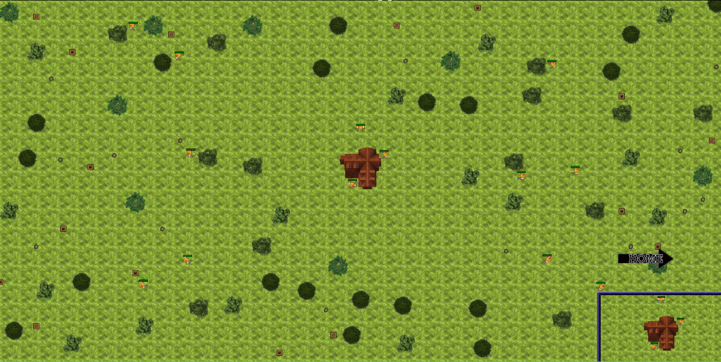

Room View

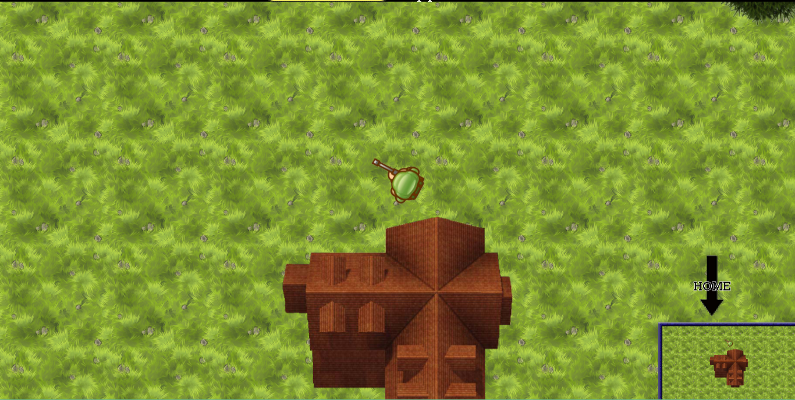Game View

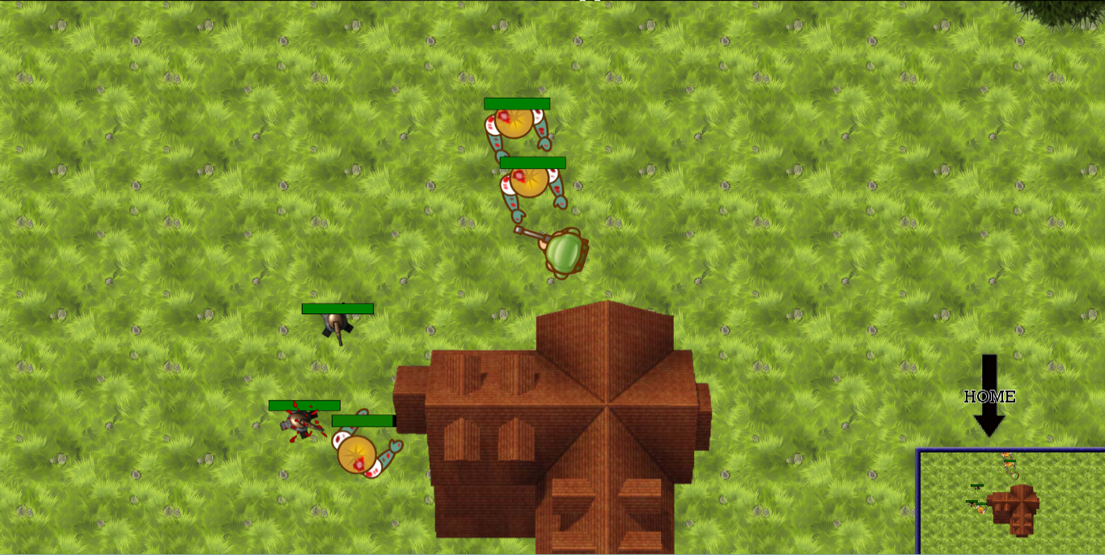Zombie and Turret Health

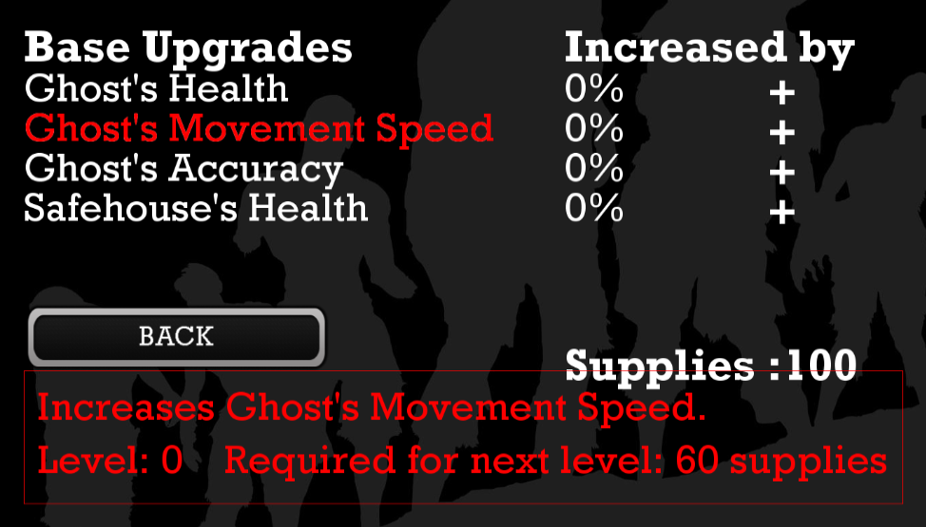

Upgrade System

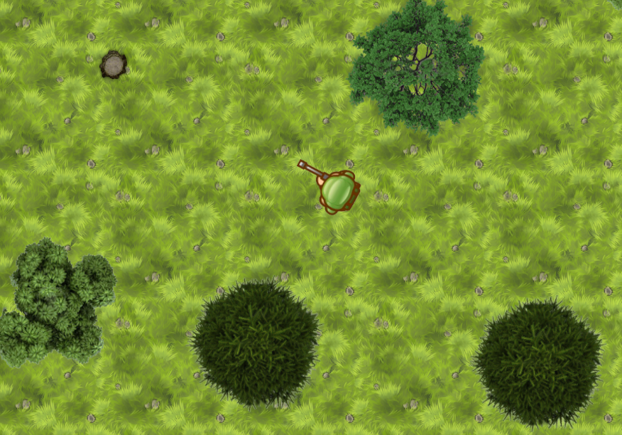Random Tree Spawning

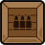

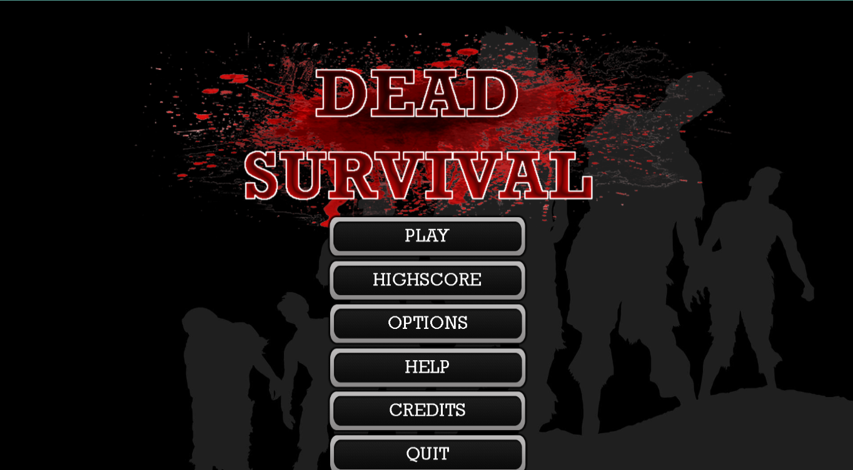Main menu

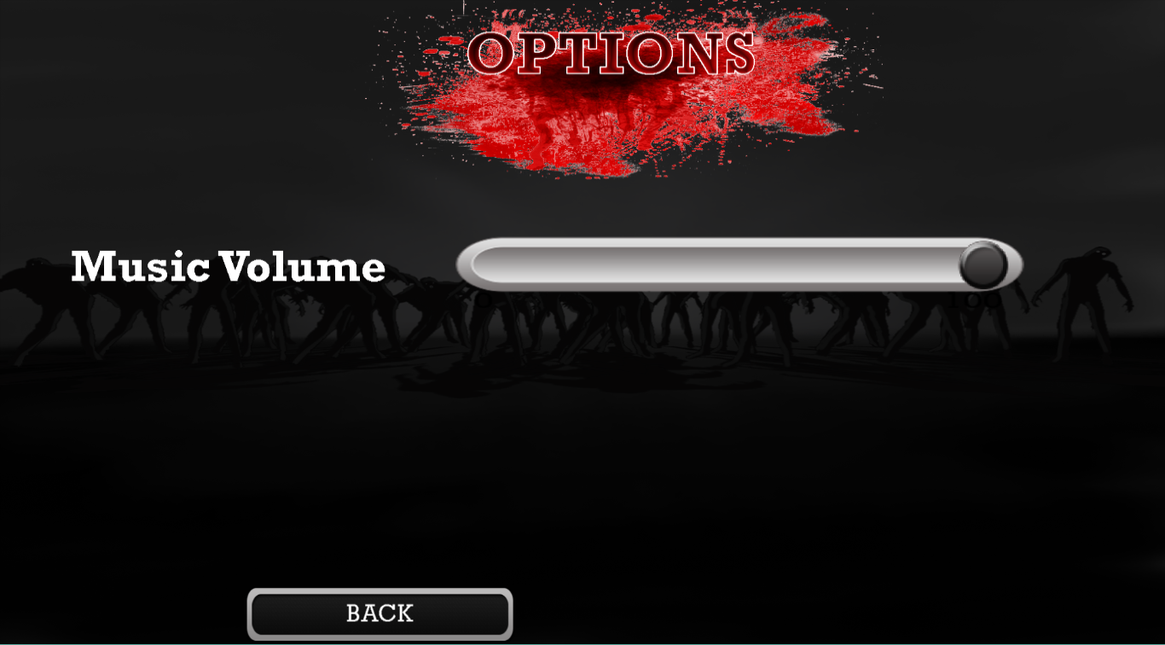Options